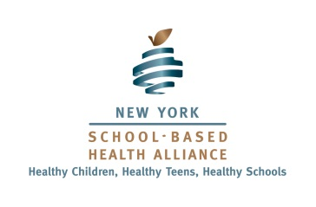
JOIN the Alliance on Advocacy Day 2-9-15 and receive a 10% discount for 2015!

Join The Alliance!
Our mission is to ensure public policies that guarantee every school-aged child in New York State, unimpeded access to quality, comprehensive medical, dental, and mental health care services. Your membership and active involvement play an essential role in the Alliance’s ability to achieve its vision of "Healthy Children, Healthy Teens, and Healthy Schools."

Select your Membership Level
Individual Member - $50.00 (USD) Parent - $10.00 (USD) Youth - Free
Children's Advocates - $100.00 (USD) Unions, CDF and Residency programs.
Education Partner: Large (More than 2,000 Students) - $250.00 (USD)
Education Partner: Principals - $100.00 (USD)
Education Partner: Regular (Less than 2,000 Students) - $150.00 (USD)
Mental Health Partner: Large (More than 4 Practices) - $250.00 (USD)
Mental Health Partner: Regular (1-4 Practices) - $150.00 (USD)
Sponsoring Organization: Large (10 or more SBHCs) - $3,000.00 (USD)
Sponsoring Organization: Medium (5-10 SBHCs) - $2,000.00 (USD)
Sponsoring Organization: Small (1-4 SBHCs) - $1,000.00 (USD)
First Name: ______________________________________________________________________
Last Name: ______________________________________________________________________
Email: __________________________________________________________________________
Address: ________________________________________________________________________
City/State/Zip Code: _______________________________________________________________
*Organization: ____________________________________________________________________
*Phone: _________________________________________________________________________
*Title: ___________________________________________________________________________
*County: _________________________________________________________________________
*Optional for Individuals, Parents and Youth applicants

___ YES! I want to join the New York School-Based Health Alliance. Please add me to the membership and email or mail the appropriate dues invoice to the address information above. (If paying by check please make check payable to NYSCSBHC)

Signature: ________________________________________________________________________
Date: ____________________________________________________________________________
New York School-Based Health Alliance
119 Washington Avenue 2nd Floor Albany, NY 12210 ▪ nysbha@gmail.com ▪ 518-694-3423 ▪ www.nysbha.org

