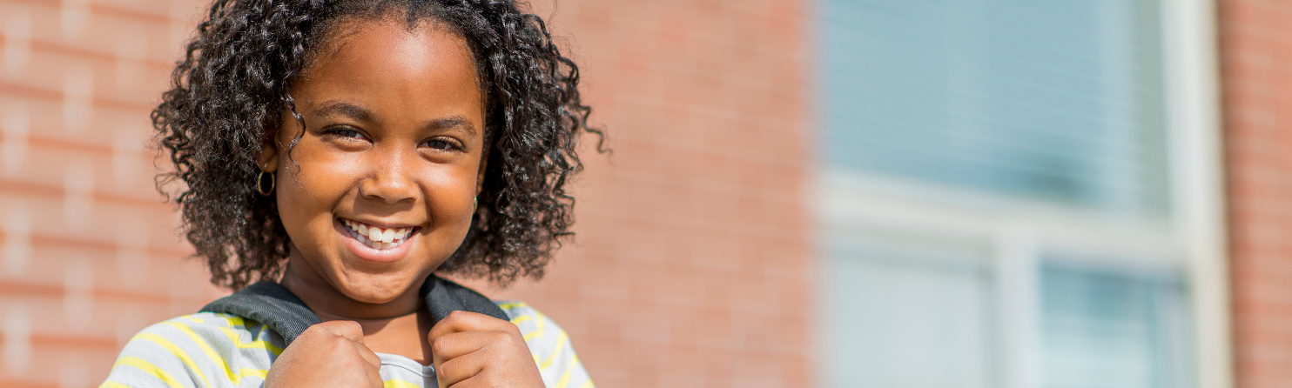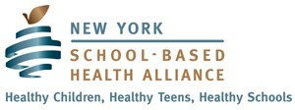

BRINGING HEALTHCARE
TO KIDS WHERE THEY ARE
SFY 2024-2025 BUDGET PRIORITIES
School-Based Health Centers (SBHCs) play a critical role in making health, mental health, reproductive health and other care accessible to children across New York with locations in the most medically underserved communities in the state. Your leadership and support has never been needed more to protect the future of this vital, child-centered model.
PRIORITY #1: Support $3.8 Million Legislative Add
Over the last decade, SBHCs have sustained the largest cuts in the program’s 45-year history. Following multiple across-the-board cuts in SFYs 2014 and 2018, the Department of Health established a new funding methodology that resulted in major reductions ranging from 25-70% of total grant funds to 27 SBHC sponsors in some of the most medically underserved areas of the State. In SFY 2019, the Cost-of-Living Adjustment (COLA) for SBHCs was permanently eliminated. As a result of this systemic disinvestment, SBHCs across the state ﬁnd themselves in ﬁnancial crisis while the need for school-based health services continues to grow. Without SBHCs, many of these children cannot access care anywhere else.
SBHCs are incredibly grateful for the support of the NYS Legislature for providing the funds to cover a portion of the gaps created by past funding cuts. SBHCs are requesting that the Legislature include $3.8 million in the Final Budget to ensure the continued viability and operation of SBHCs.
PRIORITY #2: Support Additional $3 Million Non-Medicaid Funds as Provided in SFY 2024-25 Executive Budget
In her Executive Budget, Governor Hochul has included an additional $3 million in non-Medicaid funding for SBHCs. According to the Department of Health, this amount has been sub-allocated for speciﬁc purposes including dental health and other wrap-around supports for SBHCs. It remains unclear how much of this will go to base funding.
Additional base investment in SBHCs is critically needed to support existing centers that are under threat due to historic funding cuts. At a time when many SBHCs are struggling financially, unrestricted grant funding will directly support the day to day operations to ensure availability of services for the students who rely on them.

PRIORITY #3: Support Permanent Carve-Out of SBHCs from MMC
Since 1997, SBHCs have been carved-out of the Medicaid Managed Care (MMC) program, enabling them to receive reimbursement directly from the State on a fee-for-service (FFS) basis. Given the insurmountable costs and unresolved issues associated with carve-in implementation, it is critical that SBHCs be able to continue serving children and adolescents with Medicaid on a FFS basis permanently, as provided for in S.7840, Rivera/A.8862, Paulin.
SBHCs were initially scheduled to be transitioned into MMC in 2014. The carve-in date has been extended six times since then, most recently in February 2023, postponing the carve-in date to no sooner than April 1, 2024. While the Department has stated they do not currently plan to carve SBHCs into MMC in April 2024, the annual cycle of impending implementation places SBHCs in an uncertain and untenable position, year after year.
Unlike other carve-ins implemented by NYS DOH, this one has no ﬁscal savings associated with it. However, it will cost SBHCs and sponsors a signiﬁcant amount of money to implement, while jeopardizing care. Under the carve-in, the centers and their sponsors will face costly and insurmountable administrative challenges involving credentialing, contracting, billing, claims processing for centers, and great instability from payment delays and denials. A permanent carve-out of SBHCs from MMC will ensure they can continue focusing on what they do best – providing comprehensive and much needed health and mental healthcare services to children and adolescents in high-risk areas all across New York.
About School-Based Health Centers

The State’s 250 SBHCs provide access to services to over 250,000 children in medically underserved neighborhoods including primary, dental, mental, and reproductive health care services, as well as preventative, chronic and other types of care to underserved populations on-site in schools. They are required to provide access to care to every child who enters their door regardless of insurance status.
SBHCs are a powerful tool for reducing racial and ethnic disparities. According to the State Department of Health (DOH) 12% of patients served statewide by SBHCs are uninsured, 44% are Hispanic or Latino, and 27% are Black or African American. Sixteen percent live in rural areas where geography and shortages of health and mental health providers make access to services extremely diﬃcult. SBHCs are safety-net providers for children who are undocumented and are a critical point of care for immigrant children. For some youth, SBHCs are their only source for counseling, health screenings, reproductive care and immunizations.
The beneﬁt of SBHCs to children and adolescents is wide-ranging. They improve educational outcomes such as school performance, grade promotion, and high school completion. Improved health outcomes include the delivery of vaccinations and other recommended preventive services, lower asthma morbidity, and increases in female contraceptive use, prenatal care and birth weight.
SBHCs are an unquestionable success across the State, and they need support now more than ever to remain in operation and to continue to meet the growing needs of our most underserved children and adolescents.
Please Support the School-Based Health Center Safety Net for Children!

